SIMATS ENGINEERING (SAVEETHA SCHOOL OF ENGINEERING)
Department of Computer Science & Engineering ASSESSMENT TOOL 1 – CONCEPT MAPPING

Course Code | CSA0314 | Course Title | Data Structures
CO Assessed | CO1 | Assessment | Assessment Tool 1: Concept Mapping
Weightage | 35% of CIA | Total Marks | 100
CO4 Statement | Apply suitable data structures and ADTs for efficient problem solving by analyzing time and space complexity. (BL2, BL3)
Student Name | Sanjay Krishnan R | Reg. No. | 192521055
Section/Batch | Slot C / | Date | 03-10-2026

Sanjay Krishnan R
Code of Conduct:
I, Sanjay Krishnan R , certify that this submission is my original work and that I have adhered to the guidelines specified for this assessment. I understand that any violation of academic integrity rules will result in disciplinary action.
Signature of the student:

Criteria | Weightage | Level 4 (Exemplary) | Level 3 (Proficient) | Level 2 (Developing) | Level 1 (Beginning) | Marks
Concept Identification | 25% | Identifies all key concepts from literature accurately and comprehensively | Identifies most key concepts with minor omissions | Identifies limited concepts; some are irrelevant or missing | Fails to identify essential concepts
Linkages | 25% | Establishes clear, meaningful, and accurate relationships between concepts | Shows correct relationships with minor gaps | Relationships are weak, unclear, or partially incorrect | No meaningful relationships established
Organization | 20% | Concepts are well-structured hierarchically with logical flow and grouping | Mostly organized with minor structural issues | Some organization but lacks clear hierarchy | No logical organization or structure
Integration of Literature | 20% | Integrates multiple studies effectively to show connections and comparisons | Shows some integration of literature | Limited integration; mostly isolated concepts | No integration of literature evidence
Clarity | 10% | Concept map is clear, neat, visually structured, and easy to interpret | Generally clear with minor readability issues | Clarity is reduced; difficult to interpret in parts | Poorly presented and hard to understand

Concept Map: Speed → Memory Usage → Time Complexity → Space Complexity → Trade-Off → Optimization

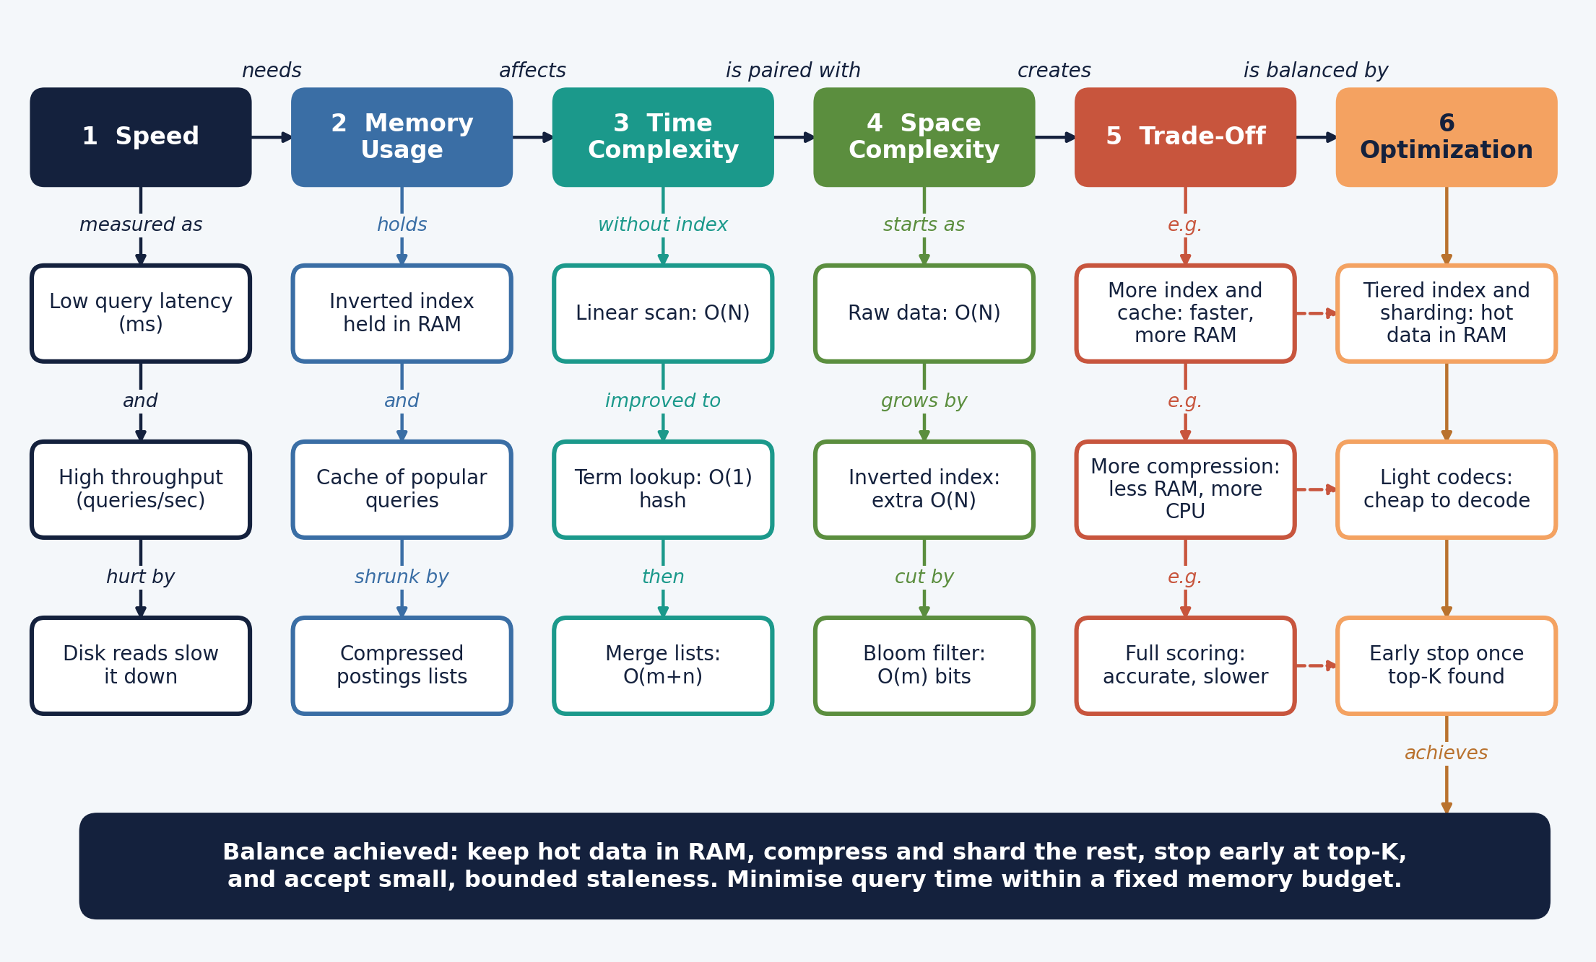
T
1. Problem Statement

A search engine must answer each query within milliseconds while searching billions of documents. Doing this forces constant decisions about how much memory to spend to save time. This report links the concepts Speed, Memory Usage, Time Complexity, Space Complexity, Trade-Off and Optimization, analyses the trade-offs between them, and justifies how a balance is reached.
2. Key Concepts

Concept | Meaning in a search engine
Speed | How quickly results appear: query latency (milliseconds per query) and throughput (queries per second).
Memory Usage | RAM consumed by the inverted index, caches and compressed postings lists. Data in RAM is far faster to reach than data on disk.
Time Complexity | How the number of operations per query grows with data size, such as O(N) for a scan versus O(1) for a hash lookup.
Space Complexity | How the storage needed grows with data size, such as the extra index on top of the raw documents.
Trade-Off | Gaining one resource costs another: lower time costs more space, and exact answers cost more time.
Optimization | Techniques that keep both time and space acceptable: caching, compression, sharding, tiering, early termination.
Inverted index | Maps each term to the list of documents that contain it, so only relevant documents are touched.

3. Linkages Between Concepts

From | Link | To | Explanation
Speed | needs | Memory Usage | Fast answers need the index and popular results held in RAM instead of read from disk.
Memory Usage | affects | Time Complexity | What is stored in memory decides how many operations a query needs. With an index, lookup is O(1) per term; without it, a scan is O(N).
Time Complexity | is paired with | Space Complexity | Lower time usually comes from precomputed structures, which raise space.
Space Complexity | creates | Trade-Off | The index adds O(N) storage beyond the raw data, so speed is bought with memory.
Trade-Off | is balanced by | Optimization | Caching, compression, sharding and early stopping reduce one cost without giving up the other.
Inverted index | reduces | Time Complexity | Only the posting lists of the query terms are read, not every document.
Compression | reduces | Space Complexity | Delta encoding and variable-byte codes shrink posting lists, at some CPU cost to decode.

4. Time and Space Complexity Analysis

N = total tokens in the collection, m and n = lengths of two posting lists, K = results returned, c = cache entries, s = number of shards.
Technique | Time | Space | Remark
Linear scan of all documents | O(N) per query | O(1) extra | Simple but far too slow at web scale.
Inverted index lookup | O(1) per term (hash) | O(N) extra | Index is built once, offline, then reused for every query.
Merge two posting lists (AND) | O(m + n) | O(1) extra | Skip pointers cut the work in practice.
Top-K ranking with a min-heap | O(n log K) | O(K) | Avoids sorting every matching document.
LRU result cache | O(1) per hit | O(c) | Repeated popular queries skip the whole pipeline.
Bloom filter | O(k) hashes | O(m) bits | Quickly rules out absent terms; false positives possible, no false negatives.
Sharding over s machines | About 1/s of the work per shard, plus a merge | s times the hardware | Shards search in parallel; their top-K lists are merged.

5. Trade-Off Analysis

Trade-off | What is gained | What is paid | Verdict
Build an inverted index | Query time drops from O(N) to a small lookup | Extra O(N) storage and index build time | Adopt: build cost is paid once, savings repeat on every query.
Cache popular queries | Very low latency for repeated queries | RAM for c entries; results can go stale | Adopt with a size limit and an expiry time.
Compress posting lists | Smaller index, more of it fits in RAM | CPU time to decode | Adopt light codecs so decoding stays cheap.
Precompute rankings | Faster responses | Slower updates, fresher data lags | Use partially, for stable popular data.
Score every match fully | Most accurate ordering | Slower queries | Limit it: score only the best candidates, stop early at top-K.
Shard and replicate | Parallel speed-up and availability | More machines and merge overhead | Adopt as data grows beyond one machine.

6. How the Balance Is Achieved

The balance can be stated as one rule: minimise query time T subject to a memory budget M. A search engine is read-heavy, so a one-time index build is cheap compared with the savings on billions of queries. That justifies spending the extra O(N) space.
Once the index exists, memory is the limited resource, so the next steps protect it. Compression keeps more of the index in RAM, and tiering keeps frequently used terms in fast memory while rare ones stay on disk. A cache absorbs repeated queries cheaply. Sharding spreads the index across machines so each one searches only a part of it in parallel.
Finally, the engine trades a little exactness for speed: it stops scoring once enough strong results are found and accepts slightly stale cached answers. Each technique removes a cost without removing the benefit, which is why the combination reaches a practical balance rather than favouring only time or only space.
7. Conclusion
Speed depends on memory, memory is measured through space complexity, and time complexity shows what that memory buys. The resulting trade-off is not removed but managed: an inverted index, caching, compression, sharding and early termination together keep responses fast while the memory used stays within budget.
8. References
- Manning, C. D., Raghavan, P., and Schütze, H. (2008). Introduction to Information Retrieval. Cambridge University Press.
- Cormen, T. H., Leiserson, C. E., Rivest, R. L., and Stein, C. Introduction to Algorithms. MIT Press.
- Bloom, B. H. (1970). Space/time trade-offs in hash coding with allowable errors. Communications of the ACM, 13(7), 422-426.
- Brin, S. and Page, L. (1998). The anatomy of a large-scale hypertextual Web search engine. Computer Networks and ISDN Systems, 30, 107-117.
- Dean, J. (2009). Challenges in building large-scale information retrieval systems. Keynote, ACM WSDM.

